**Day 78 Goals: what you will make by the end of the day**

Today we're going to analyse a dataset on the past winners of the Nobel Prize. Let's see what patterns we can uncover in the past Nobel laureates and what can we learn about the Nobel prize and our world more generally.

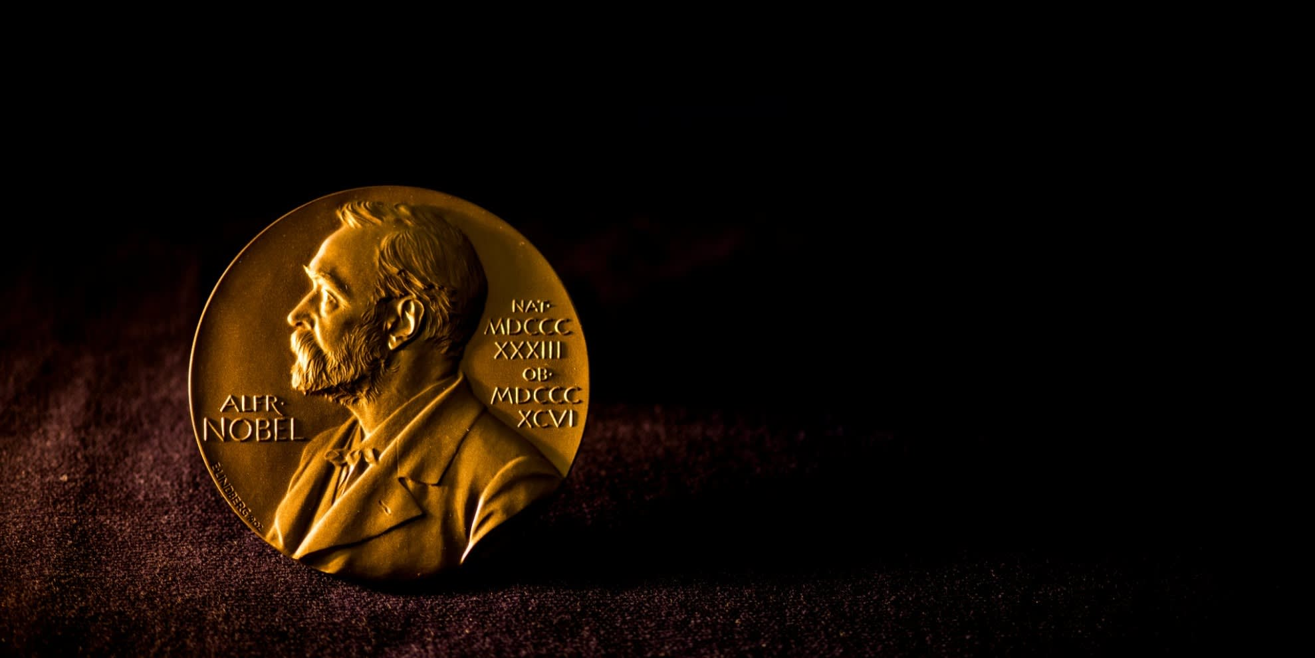

On November 27, 1895, Alfred Nobel signed his last will in Paris. When it was opened after his death, the will caused a lot of controversy, as Nobel had left much of his wealth for the establishment of a prize. Alfred Nobel dictates that his entire remaining estate should be used to endow “prizes to those who, during the preceding year, have conferred the greatest benefit to humankind”. Every year the Nobel Prize is given to scientists and scholars in the categories chemistry, literature, physics, physiology or medicine, economics, and peace.

This project will bring a lot of the tools and techniques that we've covered previously together. While we will review many concepts that we've covered in the previous days, you'll also learn a lot of new things.

**Today you'll learn:**

* Create a Choropleth to display data on a map.
* Create bar charts showing different segments of the data with plotly.
* Create Sunburst charts with plotly.
* Use Seaborn's .lmplot() and show best-fit lines across multiple categories using the row, hue, and lowess parameters.
* Understand how a different picture emerges when looking at the same data in different ways (e.g., box plots vs a time series analysis).
* See the distribution of our data and visualise descriptive statistics with the help of a histogram in Seaborn.

**Download and add the Notebook to Google Drive**

As usual, download the .zip file from this lesson and extract it. Add the .ipynb file into your Google Drive and open it as a Google Colaboratory notebook.

**Add the Data to the Notebook**

The .zip file also includes a .csv file called nobel_prize_data. This is the data for the project. Add this file to your notebook.